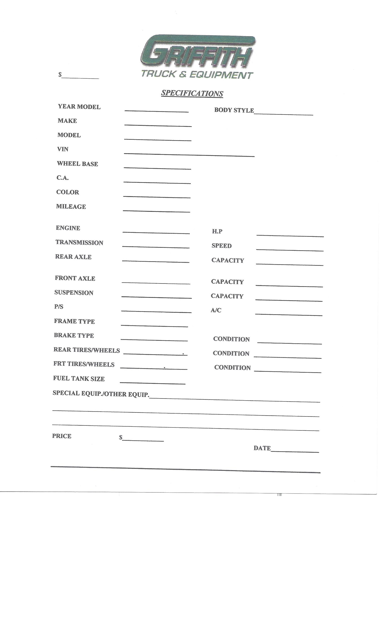
16124 I-10 East
Channelview, TX 77530
Office: 281-457-2195
Fax: 281-457-3537
www.GriffithTruck.com
Email: bgriffith@griffithtruck.com
SPECIFICATIONS
Year Model | 2018 |  | BODY STYLE |  | GARB S-L
Make | AUTOCAR
Model | ACMD42
Vin | 516M3DED4JH225028
Wheel Base | 221
C.A. | 191
Color | WHITE
Mileage | 68,632 ACTUAL
Engine | CUMMINS L9 |  | H.P. |  | 270
Transmission | ALLISON 3000 |  | Speed |  | 6
Rear Axle  Ratio | DANA S30-190  6.14 |  | Capacity |  | 30,000
Front Axle |  |  | Capacity |  | 14,000
Suspension | SPRING |  | Capacity |  | 44,000 GVW
P/S | YES TWIN |  | A/C |  | YES
Frame Type | D/F
Brake Type | AIR
Rear Tires/Wheels | 315R 22.5 |  | Condition |  | 90%
Front Tires/Wheels | 12R 22.5 |  | Condition |  | 90%
Fuel Tank Size | - 50 GAL STEEL
SPECIAL EQUIP / OTHER EQUIP |  | WAYNE 22YD AUTOMATED SIDE LOAD
Price |  |  | Date |  | 8/10/26

